Machine Learning Clustering Algorithms

Affinity Propagation:
Affinity Propagation is a clustering algorithm that automatically identifies cluster centers by exchanging messages between data points and group’s similar points together.

Key Points:
- No need to specify the number of clusters beforehand
- Automatically selects cluster centers
- Works well for small and medium datasets

Important Parameters:
- Preference → Controls how many clusters are created
- Damping factor → Helps avoid unstable updates during calculations

Drawback:
- Computationally expensive for large datasets
- Uses more memory and processing time
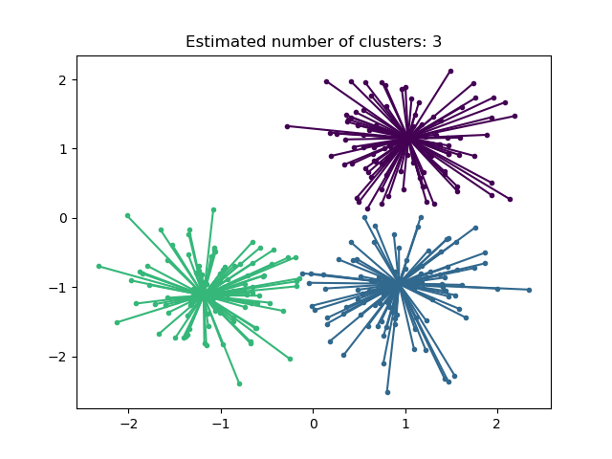

Mean Shift:
MeanShift is a density-based clustering algorithm that finds clusters by shifting cluster centers toward high-density regions in the dataset.

Key Points:
- Automatically finds the number of clusters
- Does not require specifying cluster count manually
- Works based on data density

Important Parameter:
- Bandwidth → controls the size of the search area
  - Small bandwidth → more clusters
  - Large bandwidth → fewer clusters

Advantages:
- Automatically detects clusters
- Good for irregular shaped clusters

Drawback:
- Slow for large datasets
- Requires many nearest-neighbor calculations
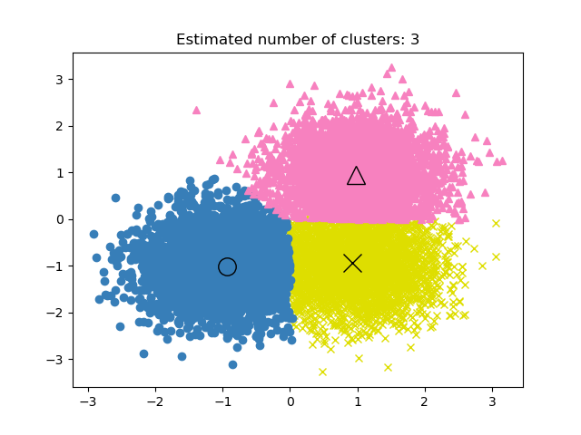

Spectral clustering
Spectral Clustering is a graph-based clustering algorithm that transforms data into a lower-dimensional space using similarity information and then groups similar points into clusters.

Key Points:
- Works well for non-linear and complex shaped clusters
- Uses similarity (affinity) between points
- Usually combined with K-Means internally

Important Parameter:
- n_clusters → number of clusters must be given manually

Advantages:
- Good for complex datasets
- Performs well on image segmentation problems

Drawback:
- Slow for large datasets
- Need to specify number of clusters beforehand

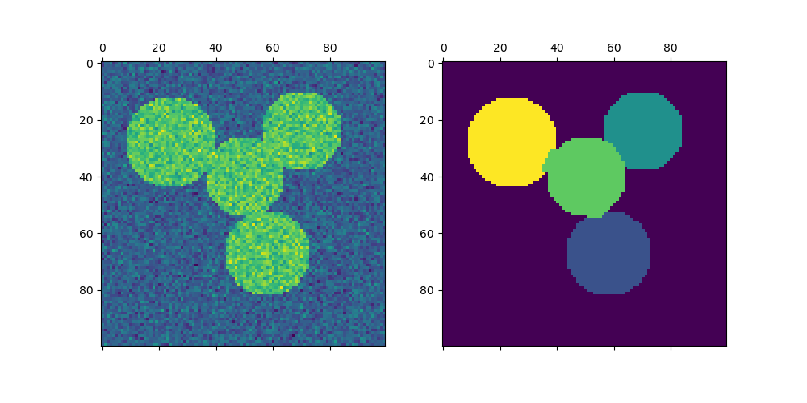
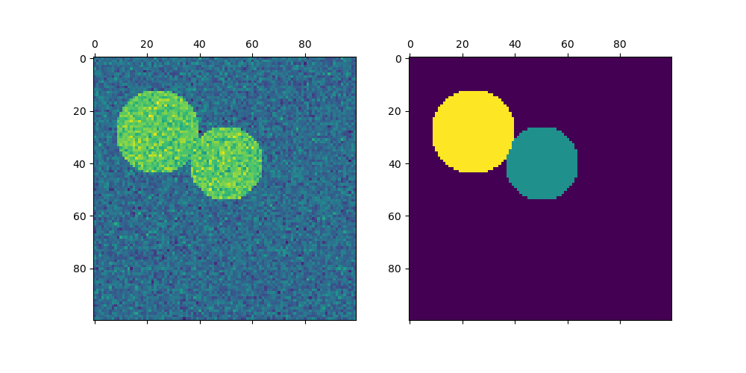

DBSCAN (Density-Based Spatial Clustering of Applications with Noise)
DBSCAN is a density-based clustering algorithm that forms clusters from closely packed data points and marks isolated points as noise or outliers.

Key Points:
- Automatically finds clusters
- Can identify outliers/noise
- Works well for irregular shaped clusters

Important Parameters:
- eps → maximum distance between neighbouring points
- min_samples → minimum points needed to form a dense region

Advantages:
- No need to specify number of clusters
- Detects noise points
- Handles non-linear clusters well

Drawback:
- Choosing correct eps value is important
- Not suitable when cluster densities vary greatly
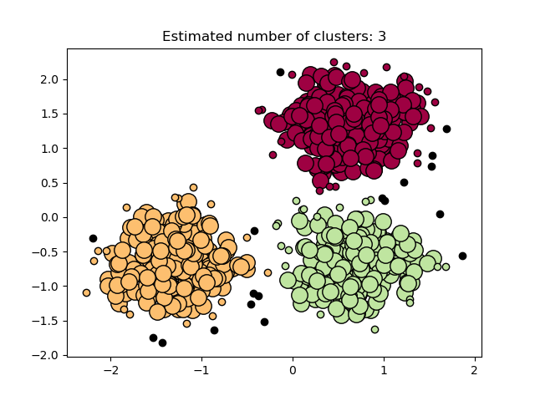

HDBSCAN (Hierarchical DBSCAN)
HDBSCAN is a density-based clustering algorithm that extends DBSCAN by automatically detecting clusters with different densities while also identifying noise and outliers.

Key Points:
- Automatically finds the number of clusters
- Detects noise/outliers
- Works well for clusters with varying densities
- More flexible than DBSCAN

Advantages:
- Better clustering accuracy than DBSCAN
- Handles complex datasets well
- No need to choose exact density threshold carefully

Drawback:
- More computationally expensive
- Slightly harder to understand and tune

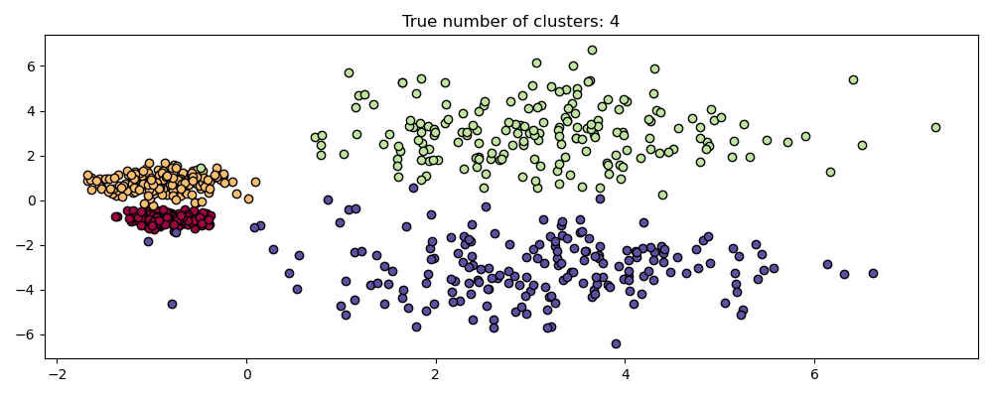

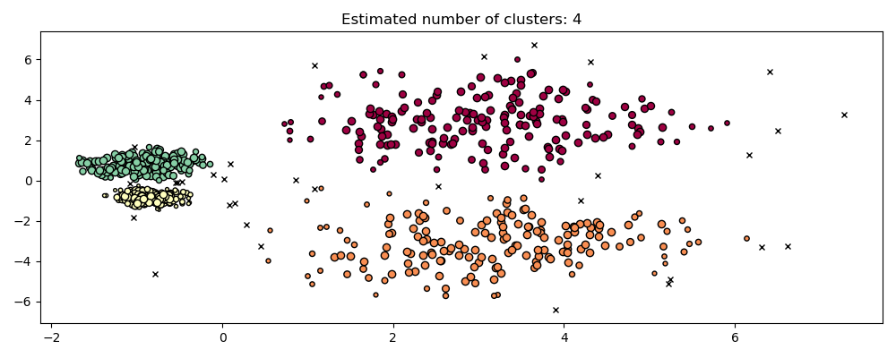

OPTICS (Ordering Points To Identify the Clustering Structure)
OPTICS is a density-based clustering algorithm that identifies clusters of varying densities by ordering data points based on reachability distance and detecting dense regions in the dataset.

Key Points:
- Extension of DBSCAN
- Handles varying density clusters well
- Detects noise points
- Creates a reachability plot for cluster analysis

Important Parameters:
- max_eps → maximum neighbourhood distance
- min_samples → minimum points needed to form a cluster
- xi → helps determine cluster boundaries

Advantages:
- Better than DBSCAN for varying densities
- Finds hierarchical cluster structures
- No need for exact eps value

Drawback:
- Slower than DBSCAN
- More complex to understand
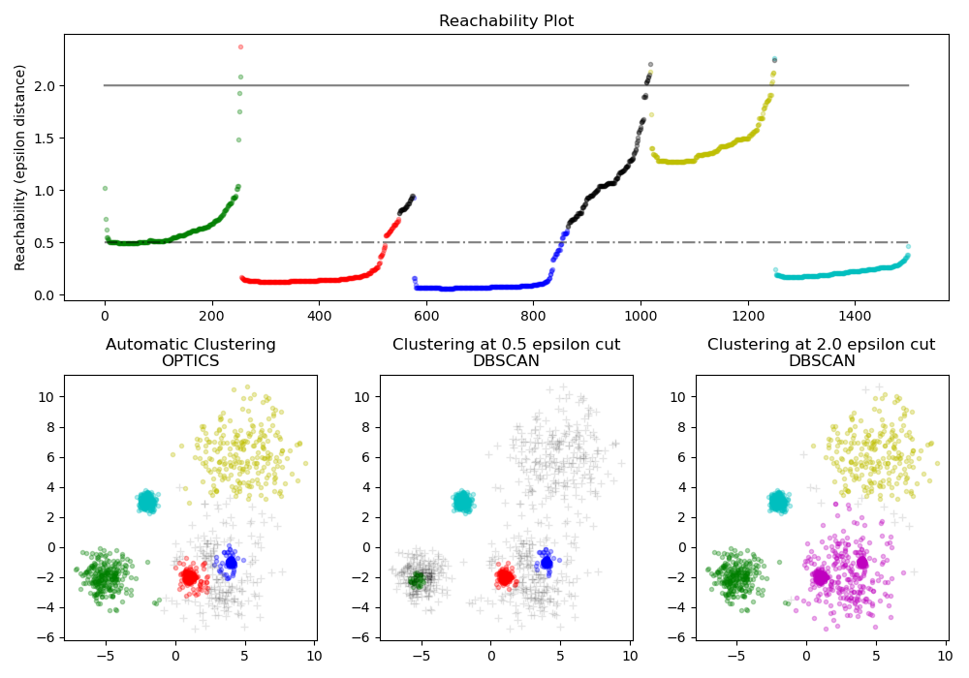

BIRCH (Balanced Iterative Reducing and Clustering using Hierarchies)
BIRCH is a hierarchical clustering algorithm that compresses large datasets into smaller sub clusters using a tree structure and then forms final clusters efficiently.

Key Points:
- Fast and memory efficient
- Suitable for large datasets
- Uses a hierarchical tree structure

Important Parameters:
- threshold → controls cluster size (default = 0.5)
- branching_factor → controls number of child nodes in the tree
- n_clusters → final number of clusters

Advantages:
- Works well for large datasets
- Uses less memory
- Faster clustering

Drawback:
- Works better for spherical clusters
- Less effective for complex cluster shapes

